Ex no: INSTALLATION OF HBASE, INSTALLING

Date: THRIFT ALONG WITH PRACTICE EXAMPLES

**Aim:**

To install Hbase and Thrift and practice examples.

**Procedure:**

1.Download the latest release of HBase from (<https://hbase.apache.org/>) and extract to /usr/local/HBase/.

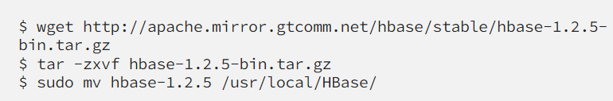

In .profile set,

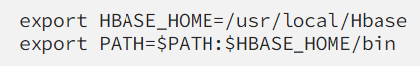



2.It requires Java 1.7 or higher else install java and add the path in **hbase-env.sh**.



3.Navigate to the HBase configuration directory (e.g., conf) and modify the **hbase-site.xml** file.Set the necessary configurations such as **hbase.rootdir** and **hbase.zookeeper.property.dataDir.**

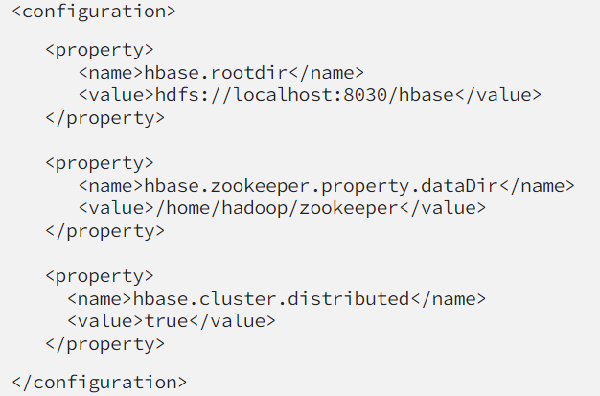

4.Start the HBase and run the command **./bin/start-hbase.sh**

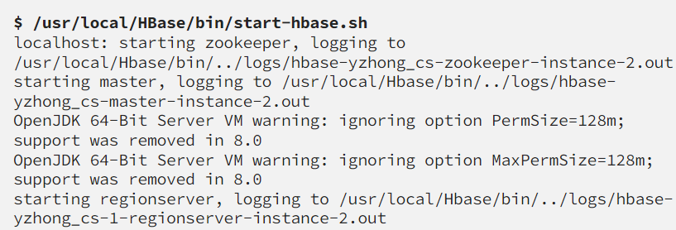

Open a web browser and go to http://localhost:16010/ to access the HBase web interface.

Ensure HBase Master and RegionServer are running.

5.Download Thrift from [**https://thrift.apache.org/**](https://thrift.apache.org/)extract to a preferred location and navigate to that directory and run

**./configure**

**make**

**sudo make install**

**thrift --version**

6.In **hbase-site.xml** file and add the following configurations:

**<property>**

**<name>hbase.regionserver.thrift.address</name>**

**<value>localhost</value>**

**</property>**

**<property>**

**<name>hbase.regionserver.thrift.port</name>**

**<value>9090</value>**

**</property>**

7.Start the HBase Thrift server by running the following command in the HBase directory.

**./bin/hbase-daemon.sh start thrift**

8.Write a Thrift client to communicate with HBase Thrift server.

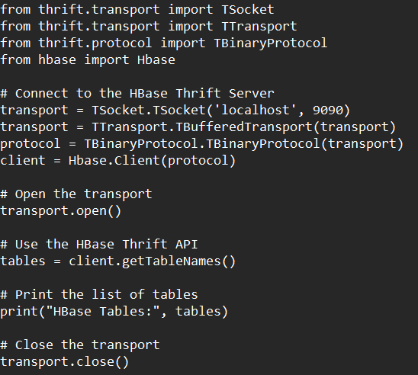

9.Run the thrift client use **create 'example_table', 'cf'** to create a table.

10.For inserting data into the created table use **put 'example_table', 'row1', 'cf:column1', 'value1'**

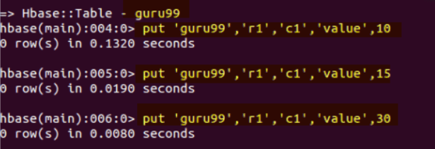

11.For deleting and fetching data **delete 'tableName', 'rowKey', 'columnFamily:qualifier', timestamp** and **get 'tableName', 'rowKey'** queries are used.

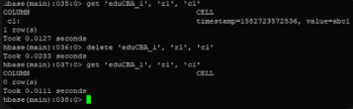

**Result:**

Thus the installation of HBase and Thrift and examples are done and verified.